**[Visualizing Match up Matrix](http://web.stanford.edu/class/archive/cs/cs448b/cs448b.1166/cgi-bin/wiki/images/a/ae/Cqiaoben_final.pdf)**

Cong Qiaoben, Stanford University

**Objective:** This paper describes a two dimensional visualization of match ups in dota2 which gives insights which are not available from one dimensional view.

**Introduction:** The match up data is a 2-dimensional matrix that represents the comparative advantage between players. The comparative advantage is computed based on the win-rate of a certain player when another player is on the other side. There some 1dimensional visualization sources which are significantly different to derive some good results. The goal of this visualization is to automatically generate a clear visualization that makes the following tasks easy to perform. The first is the comparison between players and the second is player classification.

**Methods, Visual Encoding:** The main goals of this visualization are to visualize comparison between players and player classification. This paper shows solution of this problem under the idea of clustered heatmaps. And this paper uses dot style heatmap instead of common heatmaps, since it is more easy to see pattern and distinguish colors between locations.

Example:

Using dots Common heatmap

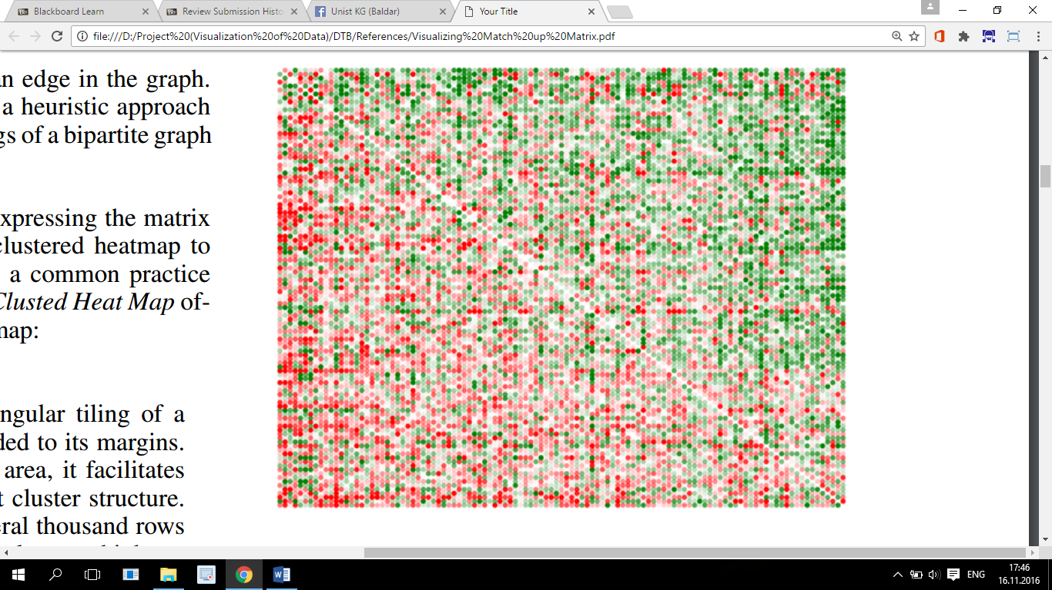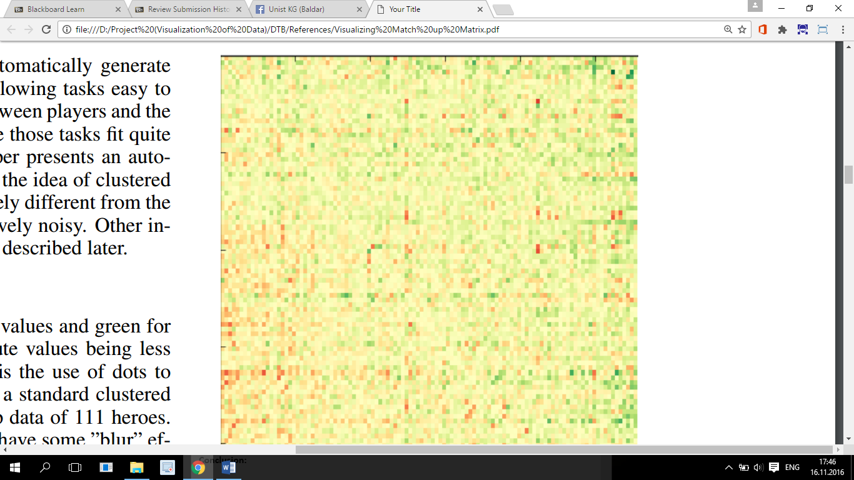

(111x111 matrix)

Color of dots here shows the percentage of advantage of the ith hero to the jth hero in ordered sequence, so to get patterns this paper uses brute force with some optimization and K-mean approaches.

**Results:**

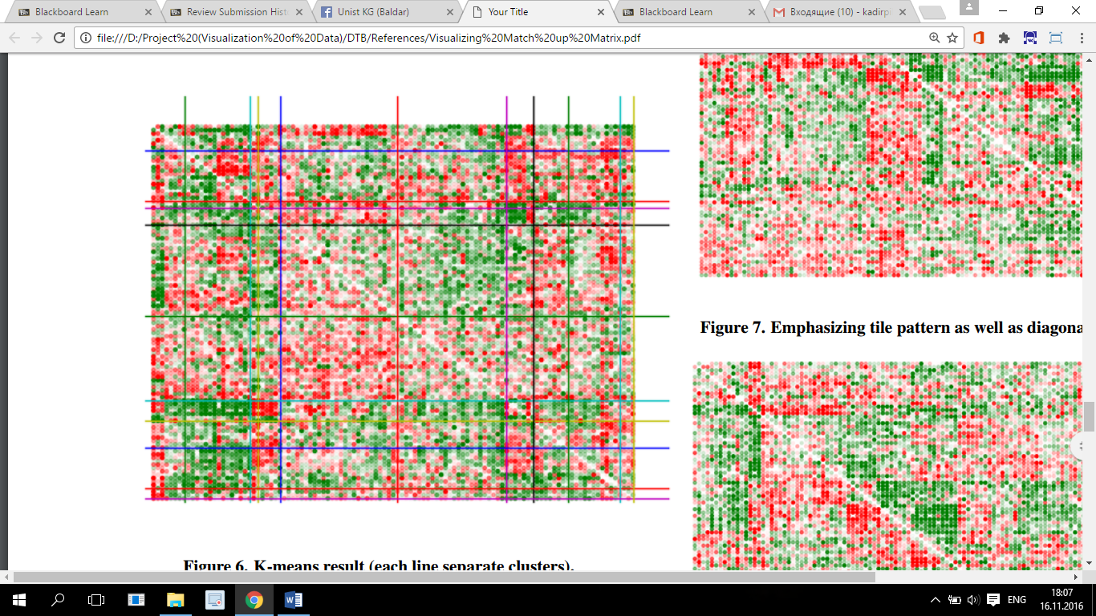k-mean where ten lines shows pattern grouping similar color in one group.

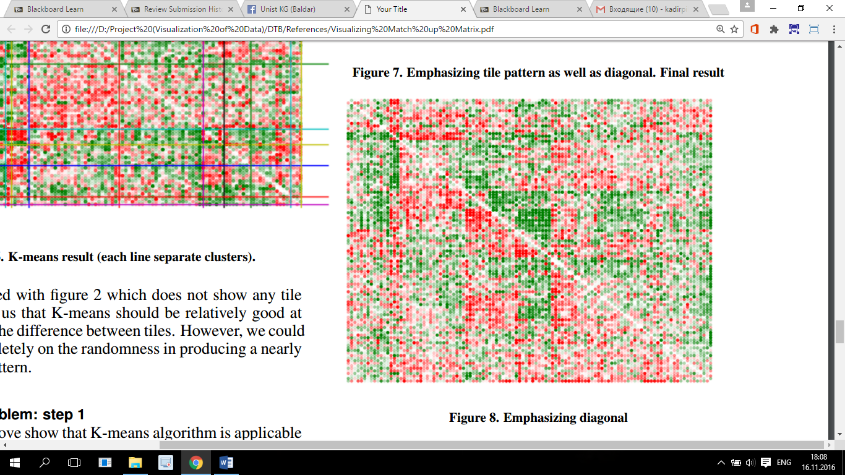This is most clearer pattern.

**Conclusion:** When I read this paper I come up with idea that I could use this paper patterns. Since this paper shows how heroes in dota2 have advantages and disadvantages playing against each other and also similar heroes has same advantage or disadvantage to another hero (cluster), it is good to show that my idea works when I use my visualization according to players relations in team or with enemy team (advantages and disadvantages).